To Shoot
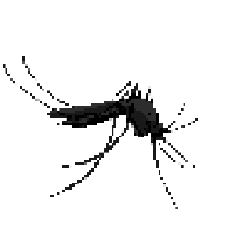 | Marsh mosquitoes  Aedes sollicitans  +2 Points  Spread Malaria
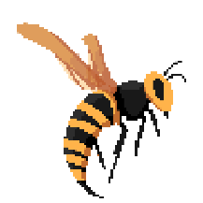 | Asian Black Hornet  Vespa velutina  +2 Points  Capture and kill Honeybee for food  String hurt :(
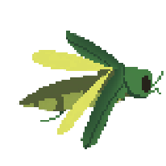 | Emerald Ash Borer  Agrilus planipennis  +3 Points  Kill Ash Tree by burrowing through them  hole make tree dead
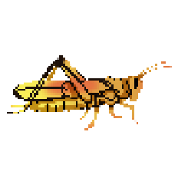 | Eastern lubber grasshopper  Romalea microptera  +3 points  Damage the Florida oranges farming industry
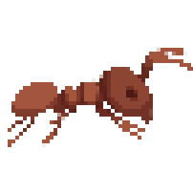 | Fire Ant  Solenopsis  +2 Points  Sting just hurt
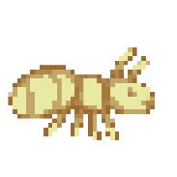 | Dracula Ant (Rare)  Mystrium camillae  +10 Points  Very fast, it stun

Not to Shoot
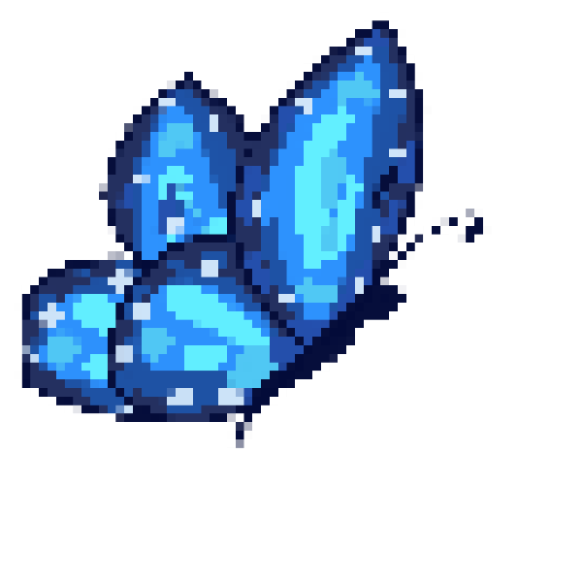 | Karner Blue Butterfly  Lycaeides melissa samuelis  -2 Points  Native to parts of the United States and Canada. This small, strikingly blue butterfly depends on wild lupine plants for survival, as its larvae feed exclusively on their leaves.  Due to habitat loss, especially the decline of wild lupine plants, the Karner Blue Butterfly is endangered and has become a symbol for conservation effort
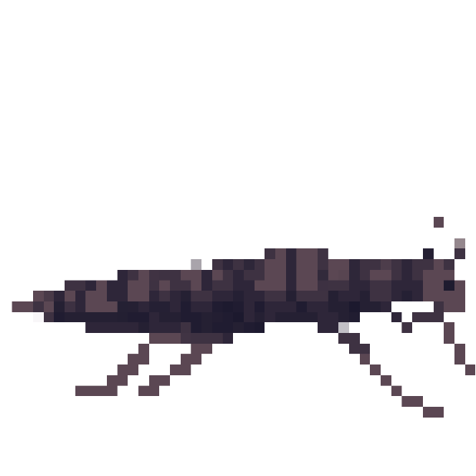 | Lord Howe Island Phasmid (Tree Lobster)  Dryococelus australis  -3 Points  Native to Lord Howe Island off the coast of Australia, this large stick insect was thought to be extinct after invasive rats devastated its population in the 1920s. However, a tiny population was discovered in 2001 on Ball's Pyramid, a remote rock island nearby.  This insect plays an important role in maintaining local ecological balance by decomposing organic matter and enriching the soil. Conservation efforts have been made to protect and reintroduce the species back to Lord Howe Island, where they could eventually contribute to the restoration of the island's original ecosystem.
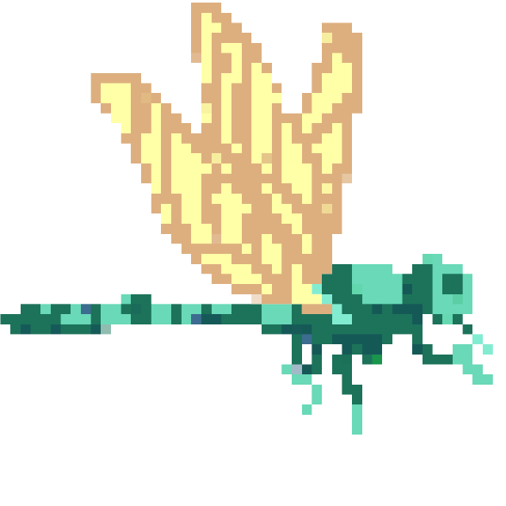 | Green Darner Dragonfly  Anax junius  -3 Points  A vibrant green thorax with blue abdomen, known for its long migratory patterns.  Status: Threatened in certain areas due to habitat loss and water pollution.

